CYBERSECURITY INTERNSHIP
Organization name:- Elevate labs

Student Name:- Mansur Hussain Syed
University:- Aditya University
Domain:- Cybersecurity
Duration:- 1st January 2026 to 30th April 2026

TASK-5: Malware Types & Behavior Analysis (Basic)

Objective
The objective of this task is to understand different types of malware, analyze their behavior using online malware analysis tools, and learn basic detection and prevention techniques. This task helps in building awareness about how malware works and how security tools identify malicious files.

Tools Used
- Primary Tool: VirusTotal
- Alternative Tool: Any.Run (Free Tier)

Introduction to Malware
Malware is short for malicious software. It is designed to harm systems, steal data, disrupt operations, or gain unauthorized access to devices. Malware can infect computers through email attachments, malicious websites, infected software, or removable media.
Types of Malware
1. Virus
A virus is a type of malware that attaches itself to legitimate files or programs. It spreads when the infected file is executed.
Characteristics:
- Requires user interaction to spread
- Attaches to executable files
- Can corrupt or delete data
Example Behavior:
- Modifies system files
- Replicates when files are opened

2. Worm
A worm is a self-replicating malware that spreads automatically across networks without user interaction.
Characteristics:
- Spreads rapidly
- Exploits network vulnerabilities
- Consumes system and network resources
Example Behavior:
- Scans networks for vulnerable systems
- Sends copies of itself to other machines

3. Trojan
A Trojan disguises itself as a legitimate application to trick users into installing it.
Characteristics:
- Does not self-replicate
- Often creates backdoors
- Used to steal data or install additional malware
Example Behavior:
- Connects to attacker-controlled servers
- Logs keystrokes or captures screenshots

4. Ransomware
Ransomware encrypts user files and demands payment for decryption.
Characteristics:
- Encrypts important data
- Displays ransom message
- Often spreads via phishing emails
Example Behavior:
- Modifies file extensions
- Blocks access to files
- Malware Analysis Using VirusTotal
Step 1: Sample Selection
Known malware file hashes were used instead of uploading actual malicious files to avoid security risks.
Step 2: Uploading Hash to VirusTotal
The malware hash was entered into VirusTotal’s search bar to retrieve analysis results.
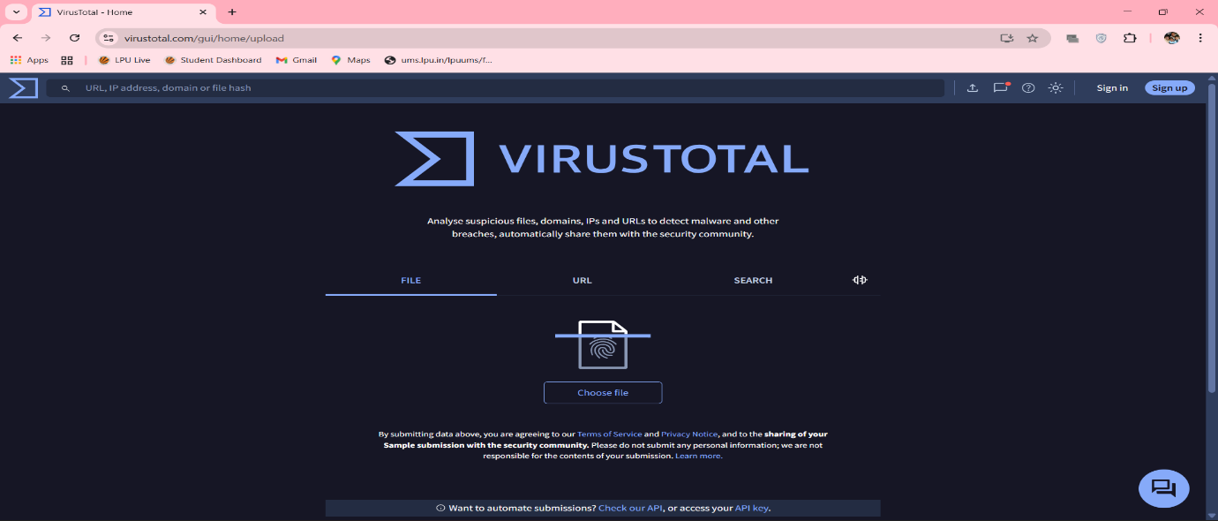

Step 3: Detection Report Analysis
VirusTotal provides:
- Number of antivirus engines detecting malware
- Malware classification (Trojan, Ransomware, etc.)
- Threat severity score
- 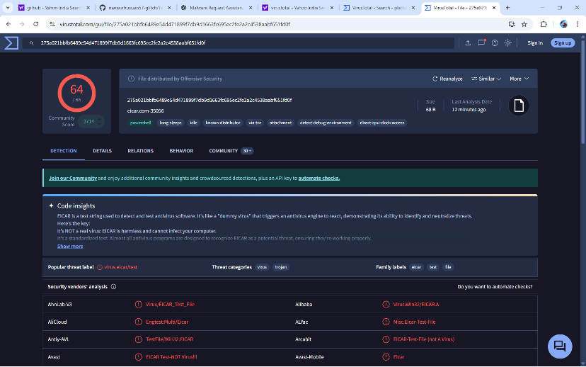

Step 4: Behavior Indicators
Observed indicators include:
- Suspicious file execution
- Network communication with malicious IPs
- Registry modification
- Persistence mechanisms

- Malware Behavior Indicators
Common behavior indicators observed:
- Creation of unknown processes
- Unauthorized file modifications
- Network traffic to suspicious domains
- Attempts to disable security services

Malware Lifecycle
- Infection / Delivery
Malware enters the system through email attachments, downloads, or removable media.
- Execution
The user unknowingly executes the malware.
- Persistence
Malware ensures it runs after system reboot.
- 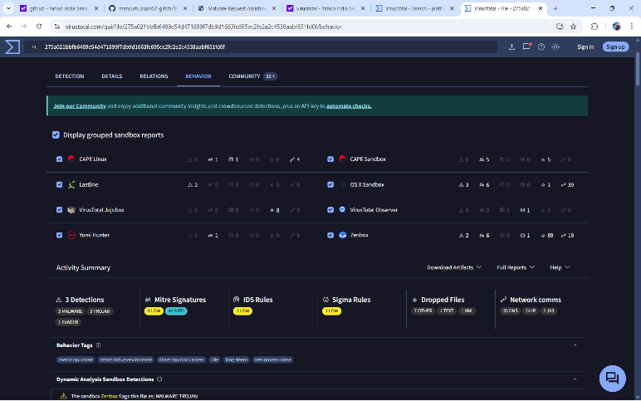

- Payload Execution
Malware performs its main malicious activity.
- Persistence
Malware ensures it runs after system reboot.
- Propagation
Malware spreads to other systems (especially worms).
- Payload Execution
Malware performs its main malicious activity. Malware Distribution Techniques
- Phishing emails
Fake software installers
Malicious advertisements
Compromised websites
Infected USB devices

- Prevention and Mitigation Techniques
Technical Controls
Antivirus and endpoint protection
Firewalls and IDS/IPS
Regular system updates and patching
User Awareness
Avoid clicking suspicious links
Verify email attachments
Download software from trusted sources
Organizational Practices
Regular backups
Security awareness training
Incident response planning

- Advantages of Using VirusTotal
Free and easy to use
Multiple antivirus engines
Provides threat intelligence
Supports hash-based analysis

- Limitations of VirusTotal
No real-time execution environment
Limited behavioral visibility
Not suitable for deep malware reverse engineering

- Key Observations
Malware detection improves when multiple engines are used
Behavior indicators help understand malware intent
Ransomware poses high risk due to data encryption
Prevention is more effective than recovery

Conclusion
This task provided practical exposure to malware classification and basic behavior analysis. Using VirusTotal, different malware characteristics and indicators were studied. The task enhanced understanding of how malware operates, spreads, and can be detected using security tools.

- Outcome
Improved malware awareness
Understanding of malware behavior
Hands-on experience with VirusTotal
Knowledge of prevention strategies

